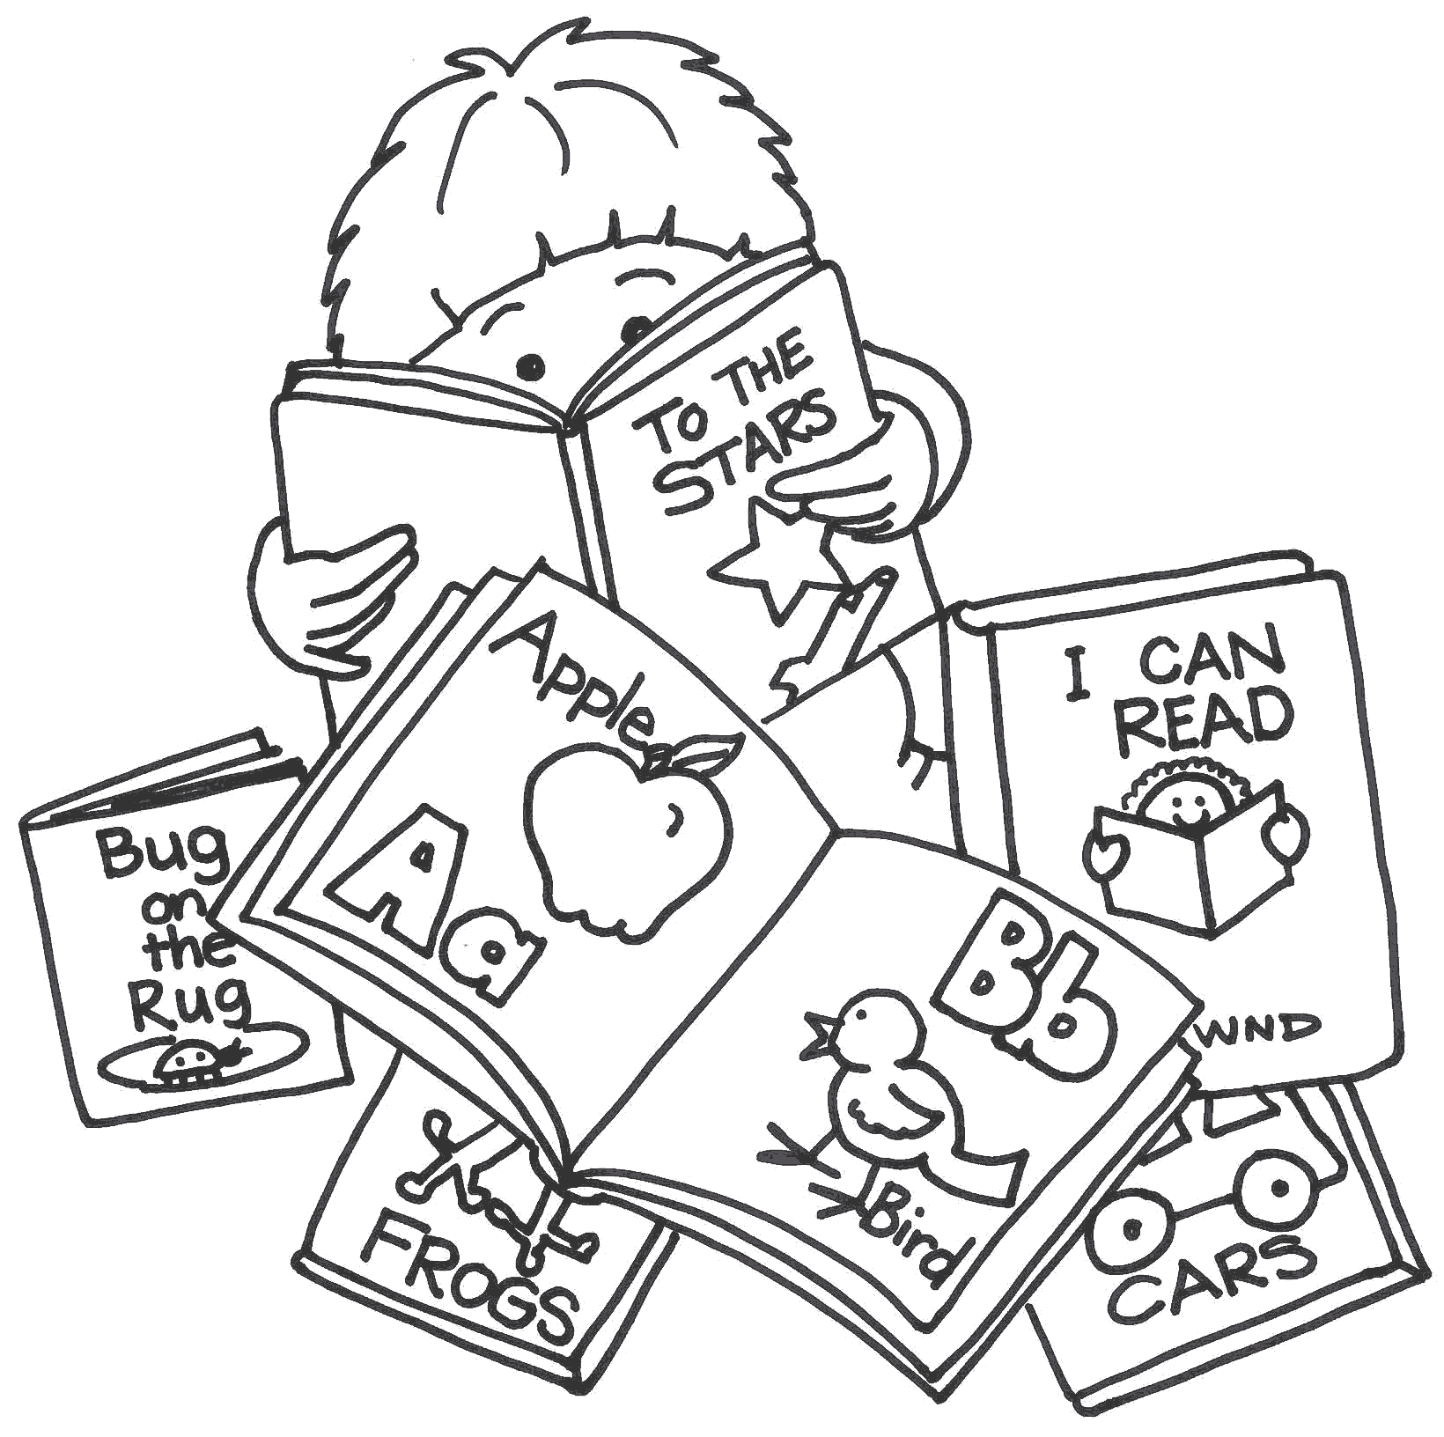 PMO SUPPLY LIST

- Book bag that can fit folder and change of clothes
- 1 Folder for Artwork & Announcements
- $20 Classroom fee
- 4 Containers of anti-bacterial hand wipes (Wet Ones)
- 3 Refills of baby wipes
- 2 containers of Clorox wipes
- 2 Rolls of 4 gallon trash bags
- 1 Ream of Copy Paper
- Roll of Paper towels

