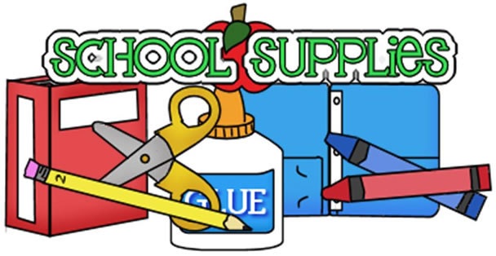

Ms. Christina’s 3-day 4’s Supply List

THESE ITEMS DO NOT NEED TO BE LABELED

- 1 pack of glue sticks
- 1 bottle of hand sanitizer
- 1 container of baby wipes
- 2 bottle of Clorox Anywhere
- 1 container of Clorox Wipes
- 1 box of tissues
- 1 box of crayons
- 1 box Ziploc Gallon size bags

- Please put your child’s name on the following:

- 1 Backpack (NO MINI) (MUST FIT REGULAR SIZE FOLDER and Lunch Box)
- 1 Lunch box
- 1 two-pocket folder
- 1 spiral notebook (with lines)
- Change of clothing (in a Ziplock Bag (labeled with child’s name)/appropriate for the season)
- Family Photo (will be displayed on our “family wall”)
- $20.00 Classroom fee

OFFICE SUPPLIES
1 REAM OF COPY PAPER
1 PACKAGE OF 9” UNCOATED THIN WHITE PAPER PLATES

