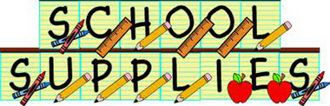

Ms. Christina’s 2-day 3’s Supply List

THESE ITEMS DO NOT NEED TO BE LABELED

- 1 pack of glue sticks
- 1 bottle of hand soap
- 1 box of ziplock sandwich bags size bags
- 1 roll of paper towels
- 2 Lysol Spray
- 1 container of Clorox Wipes
- 1 box of ziplock snack bags
- 1 ream of copy paper
- 1 package wiggle eyes

Please put your child’s name on the following:

- 1 Backpack (NO MINI) (MUST FIT REGULAR SIZE FOLDER and Lunch Box)
- 1 Lunch box
- 1 two-pocket folder
- 1 spiral notebook (with lines)
- Change of clothing (in a Ziplock Bag (labeled with child’s name)/appropriate for the season)
- Family Photo (will be displayed on our “family wall”)
- $15.00 Classroom fee

