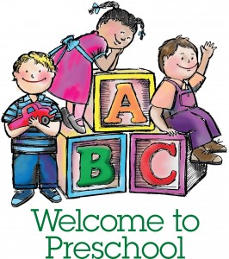
Mrs. Morrison’s 3 Day Supply List

- Large backpack to hold lunch box and folder
  - (Please, no backpacks with wheels)
- Pocket folder
- Lunch box
- $20 classroom fee
- Family Picture-which will be displayed on our family wall.
- 1 Spiral notebook ( 8 ½ x 11)
- 2 Clorox wipes
- 1 Liquid hand soap
- Gallon Ziplock bags
- 1 Package Large googly eyes
- 4 Elmers Glue Sticks
- 1 Box of 24 Crayola Crayons
- 2 pack of baby wipes
- Change of clothes- pants, shirt, socks and two (2) pairs of underwear. Place in a Ziplock bag with child’s name on the bag.

- OFFICE SUPPLIES
1 Ream of copy paper

Please put your child’s name on the following:

- Outside of the backpack
- Folder
- Journal
- Lunch box (cups and containers)
- All clothing-including coats and sweaters

** Please bring the supplies on the day of Orientation **

