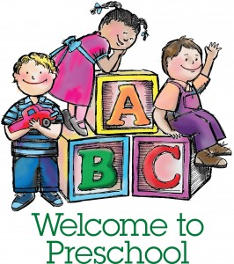
Mrs. Morrison’s 3 Day Supply List

- Large backpack to hold lunch box and folder
  - (Please, no backpacks with wheels)
- 1 Pocket folder
- Lunch box
- $20 classroom fee
- Family Picture-which will be displayed on our family wall.
- 1 Spiral notebook (8 ½ x 11)
- 2 Containers of Clorox wipes
- 1 Bottle of Liquid hand soap
- 1 Package of Gallon Ziplock bags
- 4 Elmer’s Glue Sticks
- 1 Bottle of Elmer’s Glue
- 1 Box of Crayola Crayons—24 count box
- 2 Pkgs of baby wipes
- Change of clothes- pants, shirt, socks and two (2) pairs of underwear. Place in a Ziplock bag with child’s name on the bag.

- OFFICE SUPPLIES
1 Ream of copy paper
1 Pkg of Chenille Sticks (Pipe Cleaners)

Please put your child’s name on the following:

- Outside of the backpack
- Folder
- Journal
- Lunch box (cups and containers)
- All clothing-including coats and sweaters

** Please bring the supplies on the day of Orientation **

