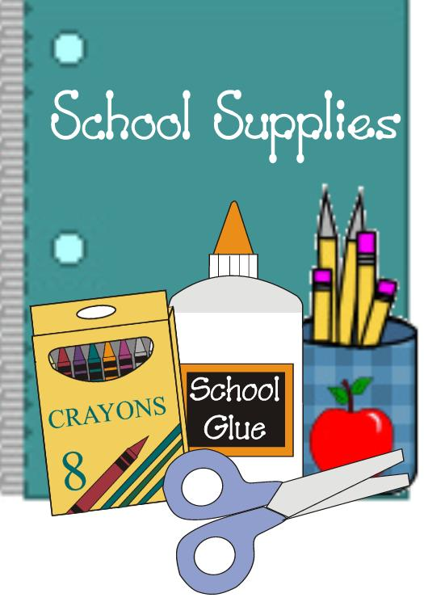
Supply List For Mrs. Jackie: 5 day 4’s

1 Container Playdoh
1 Container Clorox Cleaner Wipes
1 Bottle Elmer’s Glue
2 24 Count Box of Crayola Crayons
1 Crayola Watercolor Paint Set
1 Plastic 2 Pocket Folder with 3 Prong Fastener
1 1” Binder
1 Package Elmer’s Glue Sticks
1 Container of Baby Wipes
1 bottle of Hand Sanitizer
1 package of Washable Markers
1 Magic Eraser
1 Small Flashlight
1 Lunch Box
1 Large Backpack
1 Family Picture
1 Ream Plain Copier Paper
1 package of Wiggle Eyes
$25.00 Classroom fee for yearly Scholastic magazine and cooking

*Change of clothes to include undergarments and socks for warm and cold weather labeled with your child’s name in a Ziploc gallon bag.

**Please label your child’s name on their Lunch Box, Backpack, Clothing Ziploc Bag, and Folder ONLY. All other supplies will be shared in the classroom. Thank you!

