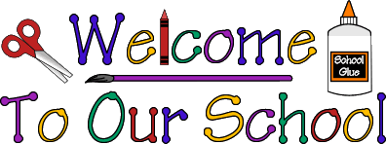

Mrs. Vicky & Mrs. Bailey’s 2 Day Supply List

- Large backpack to hold lunch box and folder
  - (Please, no backpacks with wheels)
- 2 Pocket plastic folder
- Lunch box
- $25 classroom fee
- Family Picture- to be displayed on our family wall
- 2 Containers of Clorox wipes
- 1 Liquid hand soap
- 1 Box of Sandwich Size Ziplock bags
- 1 Box of 24 count CRAYOLA Crayons
- 3 Packs of baby wipes
- 1 Box of tissues
- 1 Highlighter
- Change of clothes- pants, shirt, socks and two (2) pairs of underwear. Place in a Ziplock bag with child’s name on the bag.

OFFICE SUPPLIES

- 1 Ream of Copy Paper
- 1 Pack of Wiggle Eyes

Please put your child’s name on the following:

- Outside of the backpack
- Folder
- Lunch box
- All clothing-including coats and sweaters

** Please bring the supplies on the day of Orientation **

