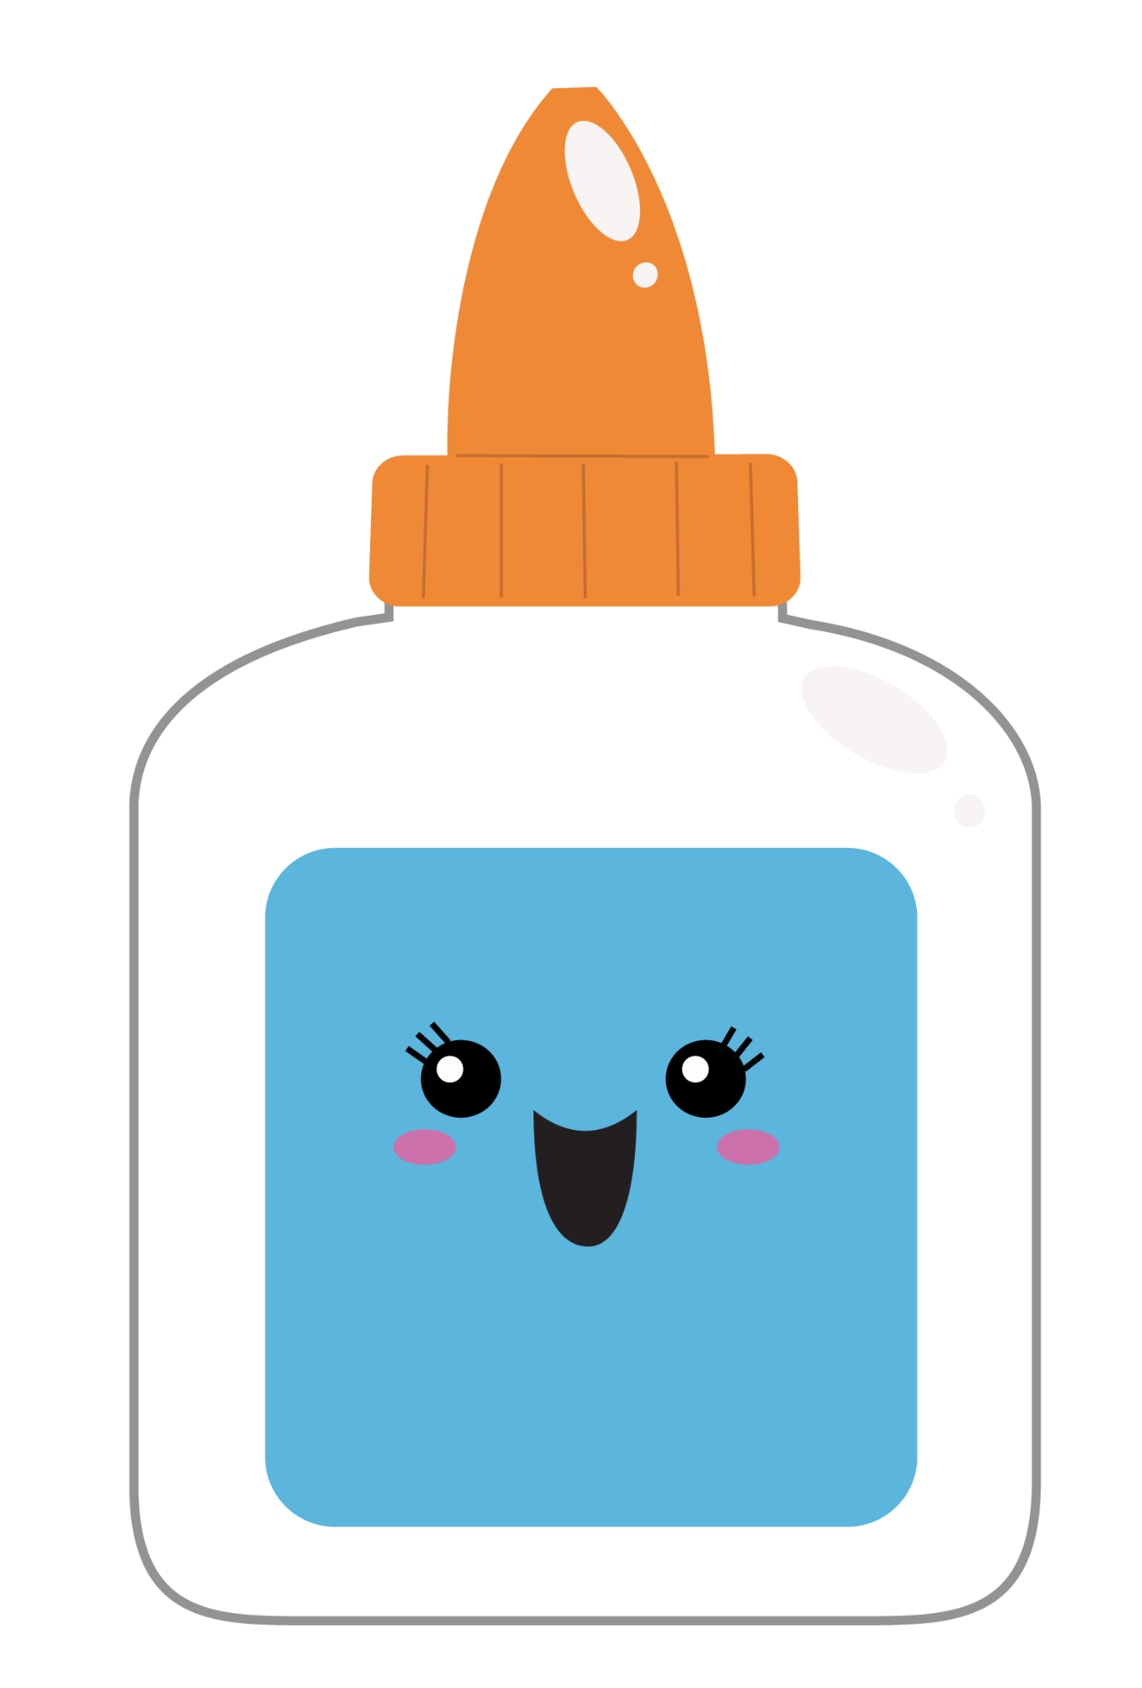

Full size backpack and Lunch box
Leak proof water bottle/cup

12x12 storage box (scrapbook paper storage- can be found at hobby lobby)
1 wide ruled 5 subject spiral notebook
1 bottle Elmer’s glue (7.625 FL OZ)
1 washable water color paint set
24 count or larger colored pencils

1 box of kleenex
2 containers of Clorox wipes
1 package small paper plates (uncoated)
1 antibacterial foaming hand soap
1 package of baby wipes
1 small package of colored card stock
$25 class fee

Office Supplies- 1 ream copy paper

*Change of clothes should include undergarments and socks for warm and cold weather labeled with your child’s name. Please place items in a gallon Ziploc bag.
*Please include your child's name on their lunch box, water bottle, backpack, and clothing.

