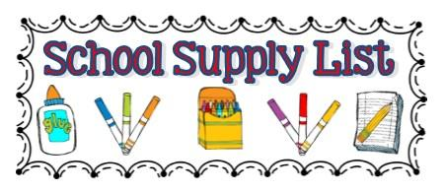

Ms. Megan /Ms. Joy
5 Day 4’s
- 1 container Clorox Wipes
- 1 Small Bottle Elmer’s Glue
- 2- 24 Count Box of Crayola Crayons
- 1 Plastic 2 Pocket Folder with 3 Prong Fastener
- 1 Composition Notebook (Wide Ruled Preferably)
- 1 Package Elmer’s Glue Sticks
- 1 Bottle Hand Sanitizer
- 1 Package Washable Markers
- 1 Box Gallon Ziploc (Boys Only)
- 1 Box Sandwich or Snack Size Ziploc (Girls Only)
- 1 Magic Eraser
- 1 Large Backpack and lunchbox
- 1 Family Picture
- $20 Classroom Fee/ Scholastic Magazine and Cooking

Office Supplies:
1 ream of paper
1 package of white card stock

Wish list:
Play dough, colored cardstocks, baby wipes

*Change of Clothes to include undergarments and socks
for warm and cold weather labeled with your child’s
name in a Ziploc Gallon Bag
*Please label your child’s name on their Lunch Box,
Backpack, Clothing, and Folder Only. All other supplies will be shared.

