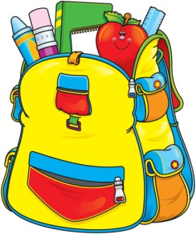
Mrs. Maria & Mrs. Becky’s
3-Day 4’s Class
Supply List 2019-2020

One sturdy two pocket folder (for correspondence between parents and teachers)
One watercolor paint set
One package colored pencils
Two box Crayola crayons (16 count)
One box Crayola washable markers
One bottle Elmer's glue
Six Elmer's glue sticks
Two containers Lysol wipes (preferably in the yellow container)
One plastic container baby wipes
One can of Lysol spray
One bottle foaming hand soap
One pump bottle hand sanitizer
One roll of paper towels
One box of gallon size Ziploc bags
One package of economy white paper plates

One family picture (to be displayed in class all year)
One change of clothing in labeled Ziploc bag (to remain in classroom)

$20 classroom fee
OFFICE SUPPLIES
1 REAM OF COPY PAPER
1 LARGE BAG OF COTTON BALLS

Please make sure student has a standard size book bag to use on a daily basis to carry folder, lunch box, snack and crafts, etc.

Please clearly label folder, lunch box (spill proof cup), family picture, change of clothing and book bag.

All other supplies will be shared and do not need to be labeled.
.

