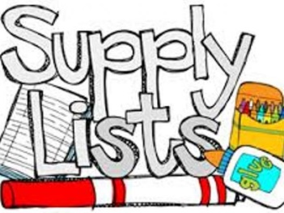
Mrs. Maria & Mrs. Becky’s
2-Day Class
Supply list 2017-2018

One sturdy two pocket folder (for correspondence between parents and teachers)
One package of colored pencils
Two box Crayola crayons (16 count)
One box Crayola washable markers
One watercolor paint set
One bottle Elmer's glue
Six Elmer’s glue sticks
Two containers Lysol wipes (preferably in the yellow container)
One spray can Lysol disinfectant
One plastic container of baby wipes
One bottle foaming hand soap
One pack of 6” white uncoated paper plates
One box of sandwich size Ziploc bags

One family picture (to be displayed in class all year)
One change of clothing in labeled Ziploc bag (to remain in classroom)

OFFICE SUPPLIES
1 REAM OF COPY PAPER
1 BAG OF COTTON BALLS

$20 classroom fee

Please make sure student has a standard size book bag to use on a daily basis to carry folder, lunch box, snack and crafts, etc.

Please clearly label folder, lunch box (spill proof cup), family picture, change of clothing and book bag.

All other supplies will be shared and do not need to be labeled.

