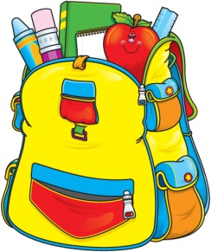
Mrs. Maria & Mrs. Becky’s
2-Day Class
Supply List

One sturdy two pocket folder (for correspondence between parents and teachers)
One watercolor paint set
One package colored pencils
Two box Crayola crayons (16 count)
One box Crayola washable markers
Two bottles Elmer's glue
10 Elmer's glue sticks
Two containers Lysol wipes (preferably in the yellow container)
One can of Lysol spray
One bottle foaming hand soap
One pump bottle hand sanitizer
One roll of paper towels
One box of gallon size Ziploc bags
One package of economy white paper plates
One pair of kid scissors
One bottle of hand sanitizer

One family picture (to be displayed in class all year)
One change of clothing in labeled Ziploc bag (to remain in classroom)

$20 classroom fee + $5 scholastic Magazine fee.
OFFICE SUPPLIES
1 REAM OF COPY PAPER

Please make sure student has a standard size book bag to use on a daily basis to carry folder, lunch box, snack and crafts, etc.

Please clearly label folder, lunch box (spill proof cup), family picture, change of clothing and book bag.

.

