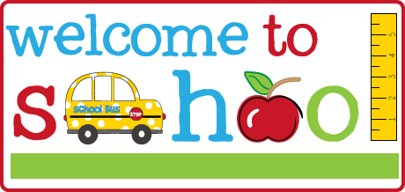

Mrs. Jefferson & Mrs. Darline’s Supply List

- $ 20 classroom fee(to include My Big World scholastics magazine)
- Family Picture-which will be displayed on our family wall.
- LARGE BACKPACK to hold lunch box and folder
- (minimum approx. 16x12 , not toddler size)
- Lunch box (easy to open)
- Pocket folder (solid plastic folder w/2 pockets)
- (2) Box of Crayola crayons (24 crayons per box)
- (1) Box of Crayola Classic markers
- (1) Crayola washable watercolors (8 colors)
- (2) Pack of Elmers Glue Stick (3 pk)
- (1) Bottle of Elmers Glue
- (1) Pair of Fiskar scissors-round tip
- (1 ) 4 pack of Play Doh (any color)
- (1) bottle of hand soap
- (1) bottle of hand sanitzer
- (2) packs of baby wipes
- (2) boxes of tissues
- (2) containers of Clorox or Lysol Wipes
- (1) box each of Quart and gallon size baggies
- Change of clothes- pants, shirt, socks and two (2) pairs of underwear. Place in a Ziplock bag with child’s name on the bag.

OFFICES SUPPLIES
1 REAM OF COPY PAPER
1 PACKAGE OF 6” WHITE paper plates (thin, economical, uncoated)

Please put your child’s name on the following:

- Backpack
- Lunch box (spill proof cup & easy to open lunch box)
- All clothing-including coats and sweaters

