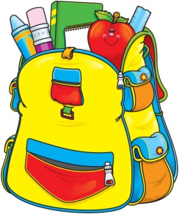
Mrs. Maria & Mrs. Becky’s
3-Day 4’s Class
Supply List

One sturdy two pocket folder (for correspondence between parents and teachers)
One watercolor paint set
One package colored pencils
Two box Crayola crayons (16 count)
One box Crayola washable markers
Two bottles Elmer's glue
12 Elmer's glue sticks
Two containers Lysol wipes (preferably in the yellow container)
One can of Lysol spray
One bottle foaming hand soap
One pump bottle hand sanitizer
One roll of paper towels
One box of sandwich size Ziploc bags
One pair of kid scissors
1-4 pk of dry erase markers

One family picture (to be displayed in class all year)
One change of clothing in labeled Ziploc bag (to remain in classroom)

$20 classroom fee + $5 scholastic Magazine fee.
OFFICE SUPPLIES
1 Ream of copy paper
1 Pkg of colored card stock (any colors)

Please make sure student has a standard size book bag to use on a daily basis to carry folder, lunch box, leak proof water bottle, snack and crafts, etc.

Please clearly label folder, lunch box (leak proof water bottle), family picture, change of clothing and book bag.

.

