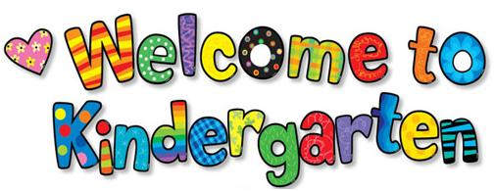

2020-2021
Mrs.Asher/Mrs. Drake
Room 6
1 backpack (large enough for lunch box and folder)
(no, rolling ones please)

1 pencil box *(5x8x2 size)
2 boxes of crayons-24 count*
1 box large size classic color magic markers (10 count)*
10 small glue sticks
2 bottle white glue-4oz*
1 pair of scissors*
1 package of 2 rolls of paper towels
1 container of Clorox wipes
1 box of tissues

OFFICE SUPPLIES

1 ream of paper
6” white paper plates (thin, economical, uncoated)

Classroom fees
$20.00 for memory book
(includes book, film development, embellishments)
$5.00 for science
(includes book and supplies)
Total - $25.00

Pencils are provided

*Please take a few minutes to label your child’s supplies.
1 set of extra clothes for emergency
(does not have to be uniform)

